## Supplemental Tables & Figures

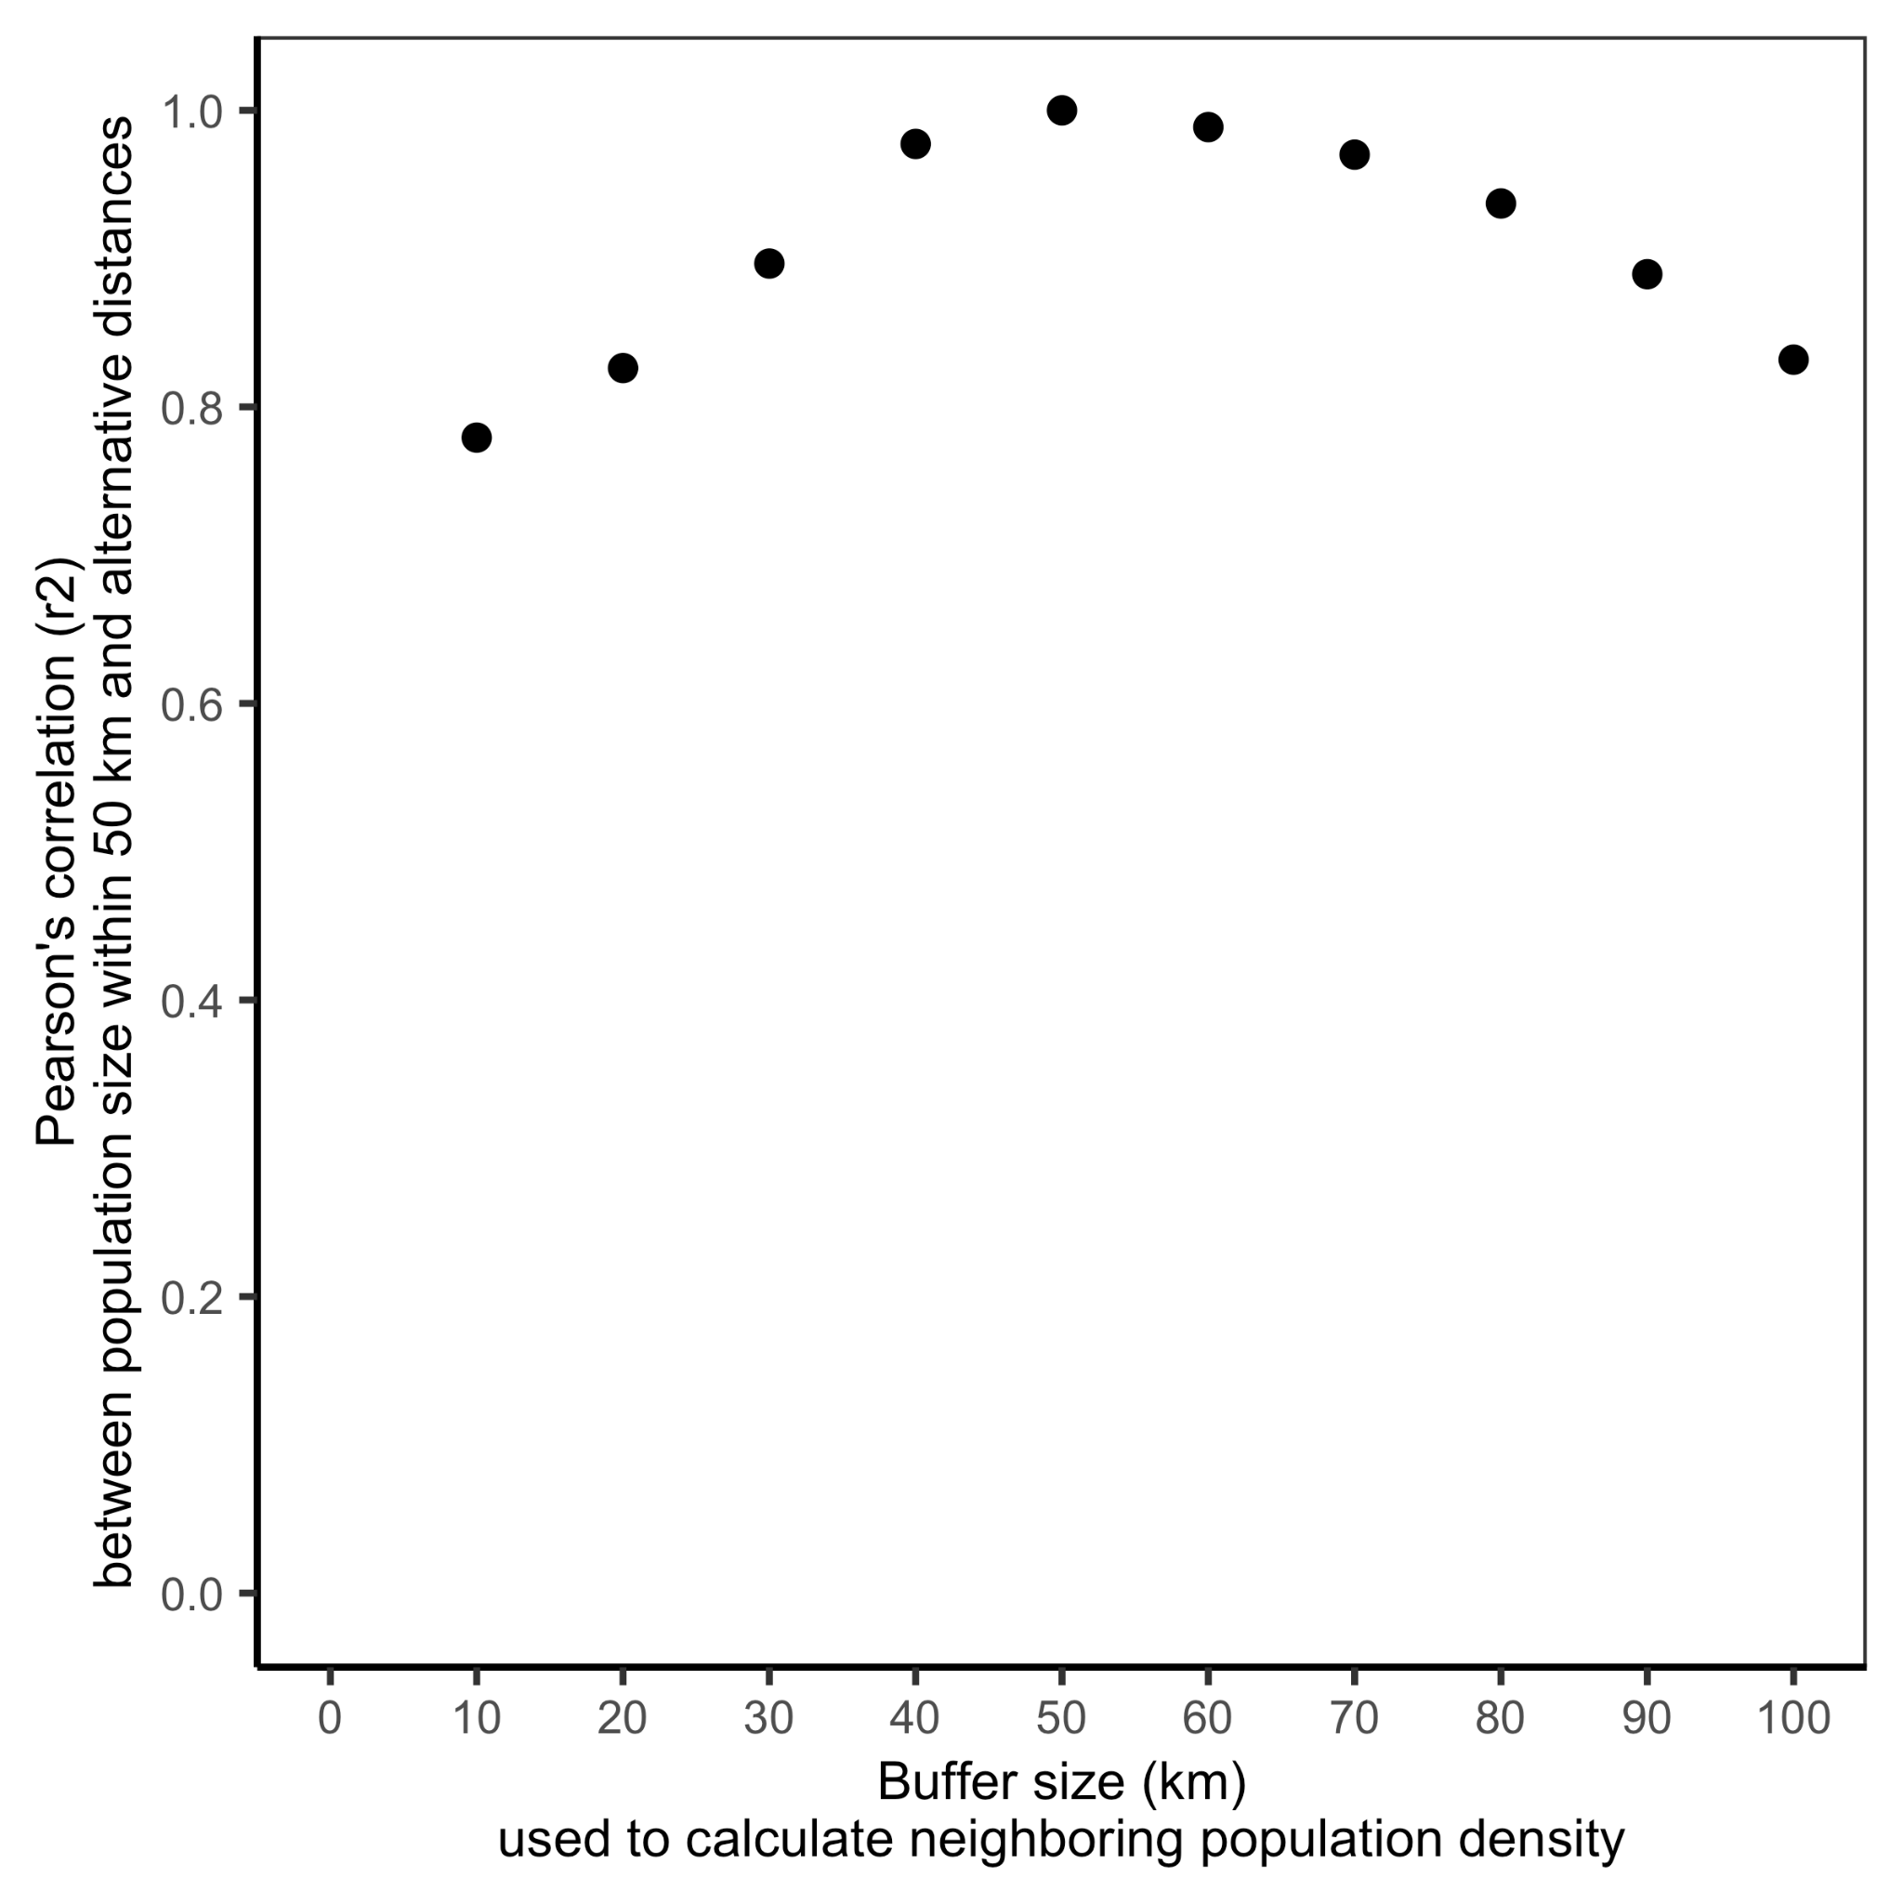

**Figure S1.** The correlation between population density calculated using the selected 50 km buffer and population densities calculated using alternative buffer distances.

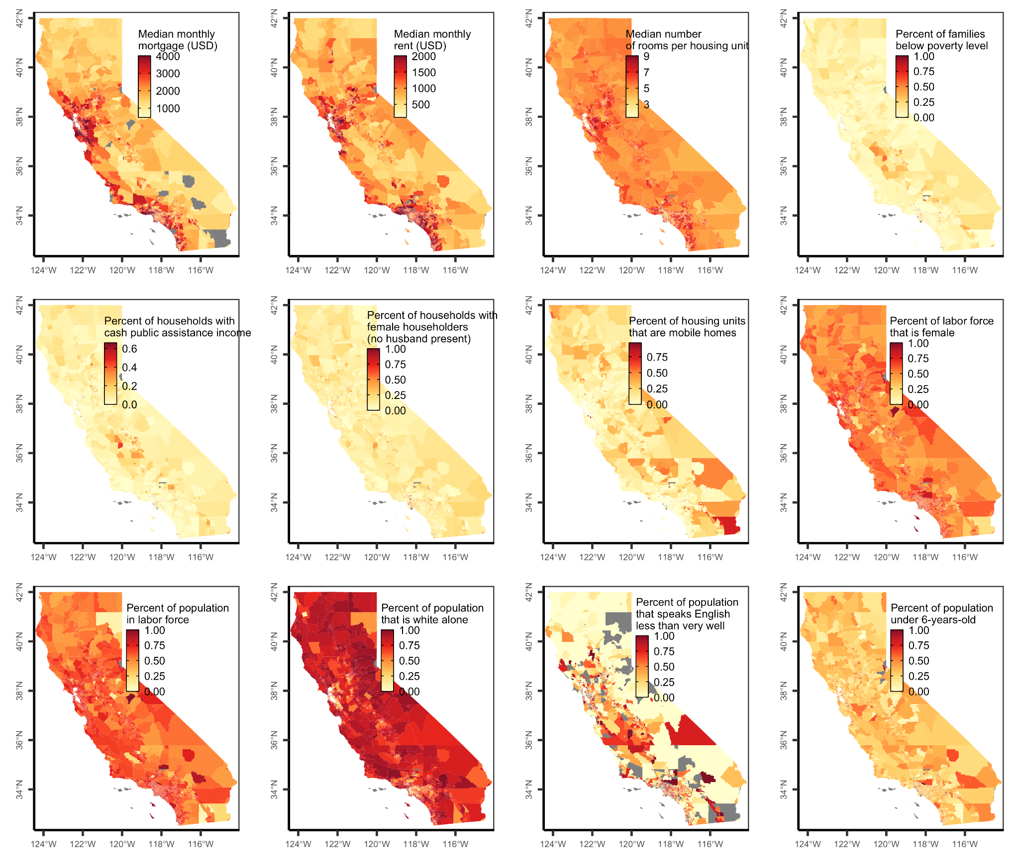**Figure S2.** Maps of the social vulnerability indicator used to calculate the social vulnerability index by California US Census tract.

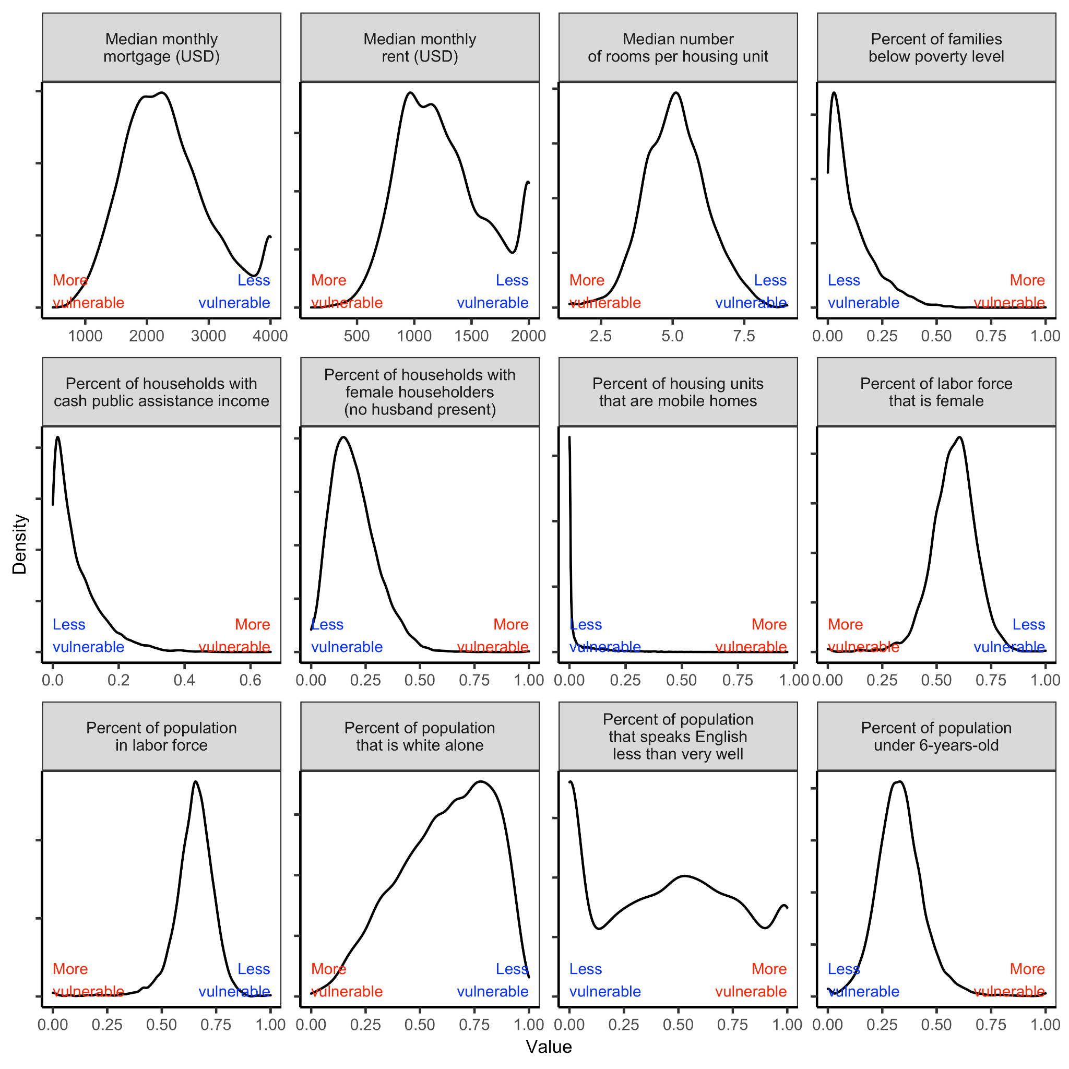**Figure S3.** Distribution of the social vulnerability indicator values by California US Census tract used to calculate the social vulnerability index. Values were centered on the statewide average and scaled to unit variance. Indicators in which higher vulnerability is indicated by higher values (e.g., percent of families below poverty level, percent of households with cash public assistance income) were multiplied by -1 so that higher vulnerability is represented as low values for all indicators. The social vulnerability index, mapped in **Figure S4**, was calculated as the average of the centered, scaled, and standardized indicators.

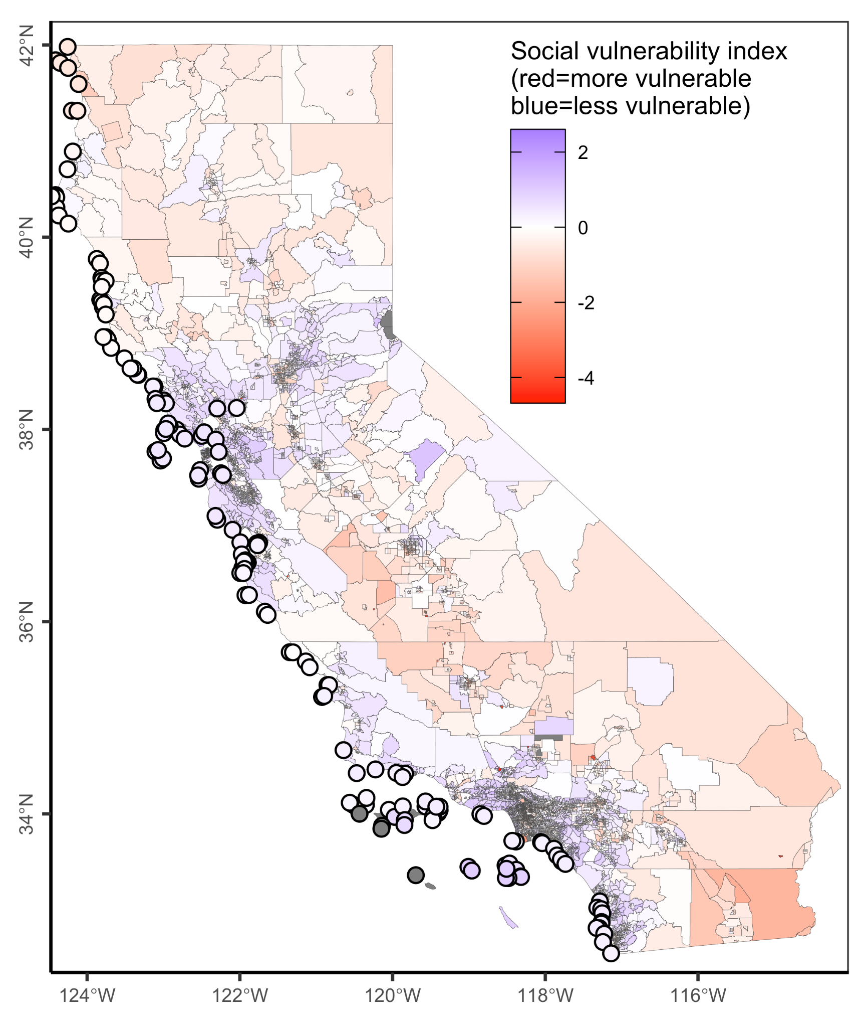

**Figure S4.** Social vulnerability index by US Census tract (polygons on land) and average social vulnerability index within 50 km of each MPA (points at sea). The social vulnerability index is calculated as the average of the 12 indicators of social vulnerability described in **Table S2**. Indicators were centered on their statewide average and scaled to unit variance before the index was calculated. Negative (red) values indicate higher social vulnerability and positive (blue) values indicate lower social vulnerability.

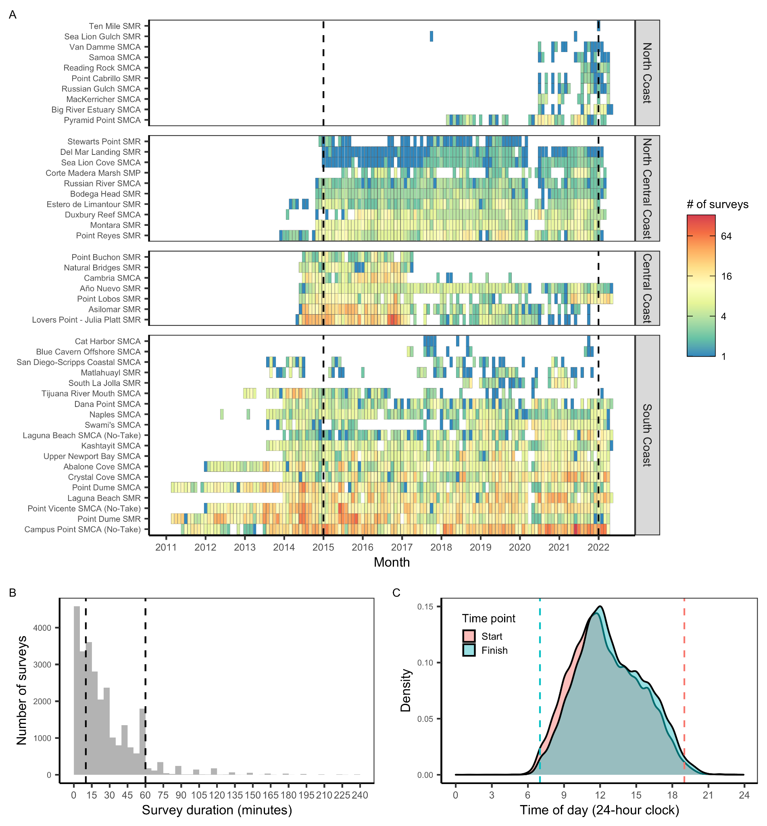**Figure S5.** The **(A)** coverage of usable MPA Watch surveys over time by marine protected area (MPA). A usable survey is a survey in which the duration was accurately recorded (i.e., end time occurs after start time). Note log-scale for fill color. San Francisco Bay MPAs are plotted in the North Central Coast region for simplicity. Only surveys occurring between January 1, 2015 and December 31, 2022 were considered in the analysis. We also excluded **(B)** surveys shorter than 10 minutes or longer than 60 minutes and **(C)** surveys ending before 7AM or starting after 7PM.

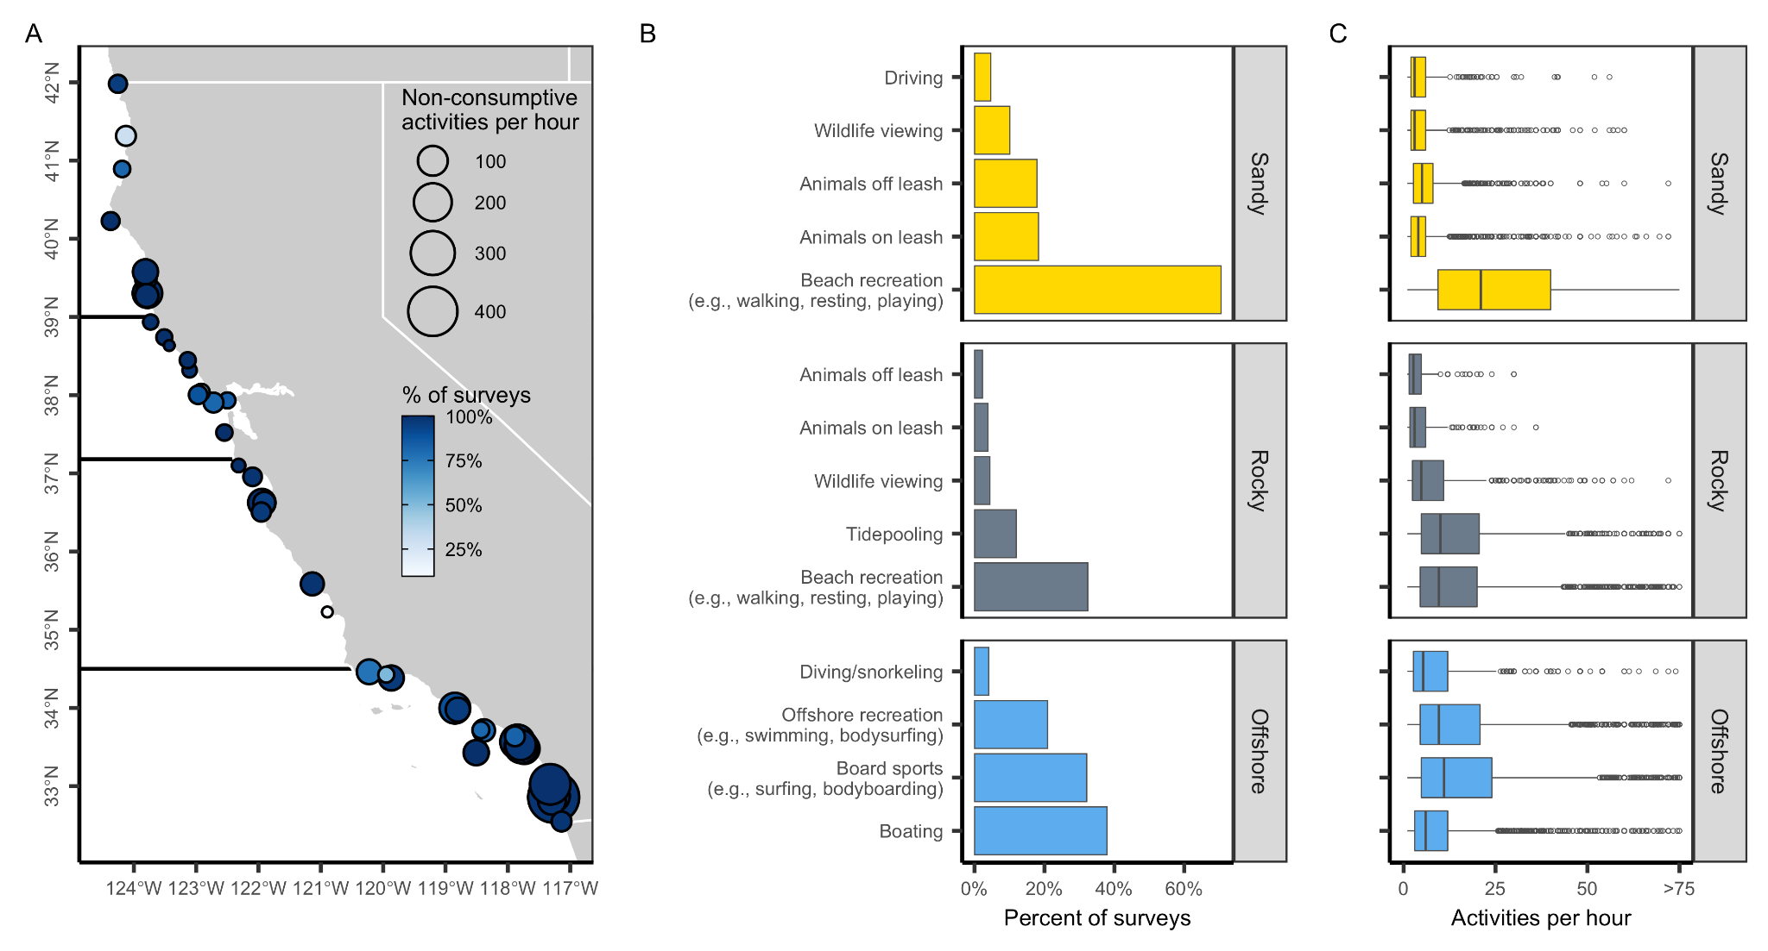**Figure S6.** Non-consumptive activities in California’s state marine protected areas (MPAs) based on surveys conducted by MPA Watch. Panel **A** shows the percent of surveys within an MPA in which non-consumptive activities were observed (color ramp) and the median number of non-consumptive activities observed per hour (point size) for surveys in which such activities were observed (i.e., zeroes excluded). Dark horizontal lines delineate the four MLPA regions. Panel **B** shows the percent of surveys in which non-consumptive activities were observed by habitat area. Panel **C** shows the number of non-consumptive activities observed per hour for surveys in which such activities were observed (i.e., zeroes excluded). In the boxplots, the solid line indicates the median, the box indicates the interquartile range (IQR; 25th to 75th percentiles), the whiskers indicate 1.5 times the IQR, and the points beyond the whiskers indicate outliers.

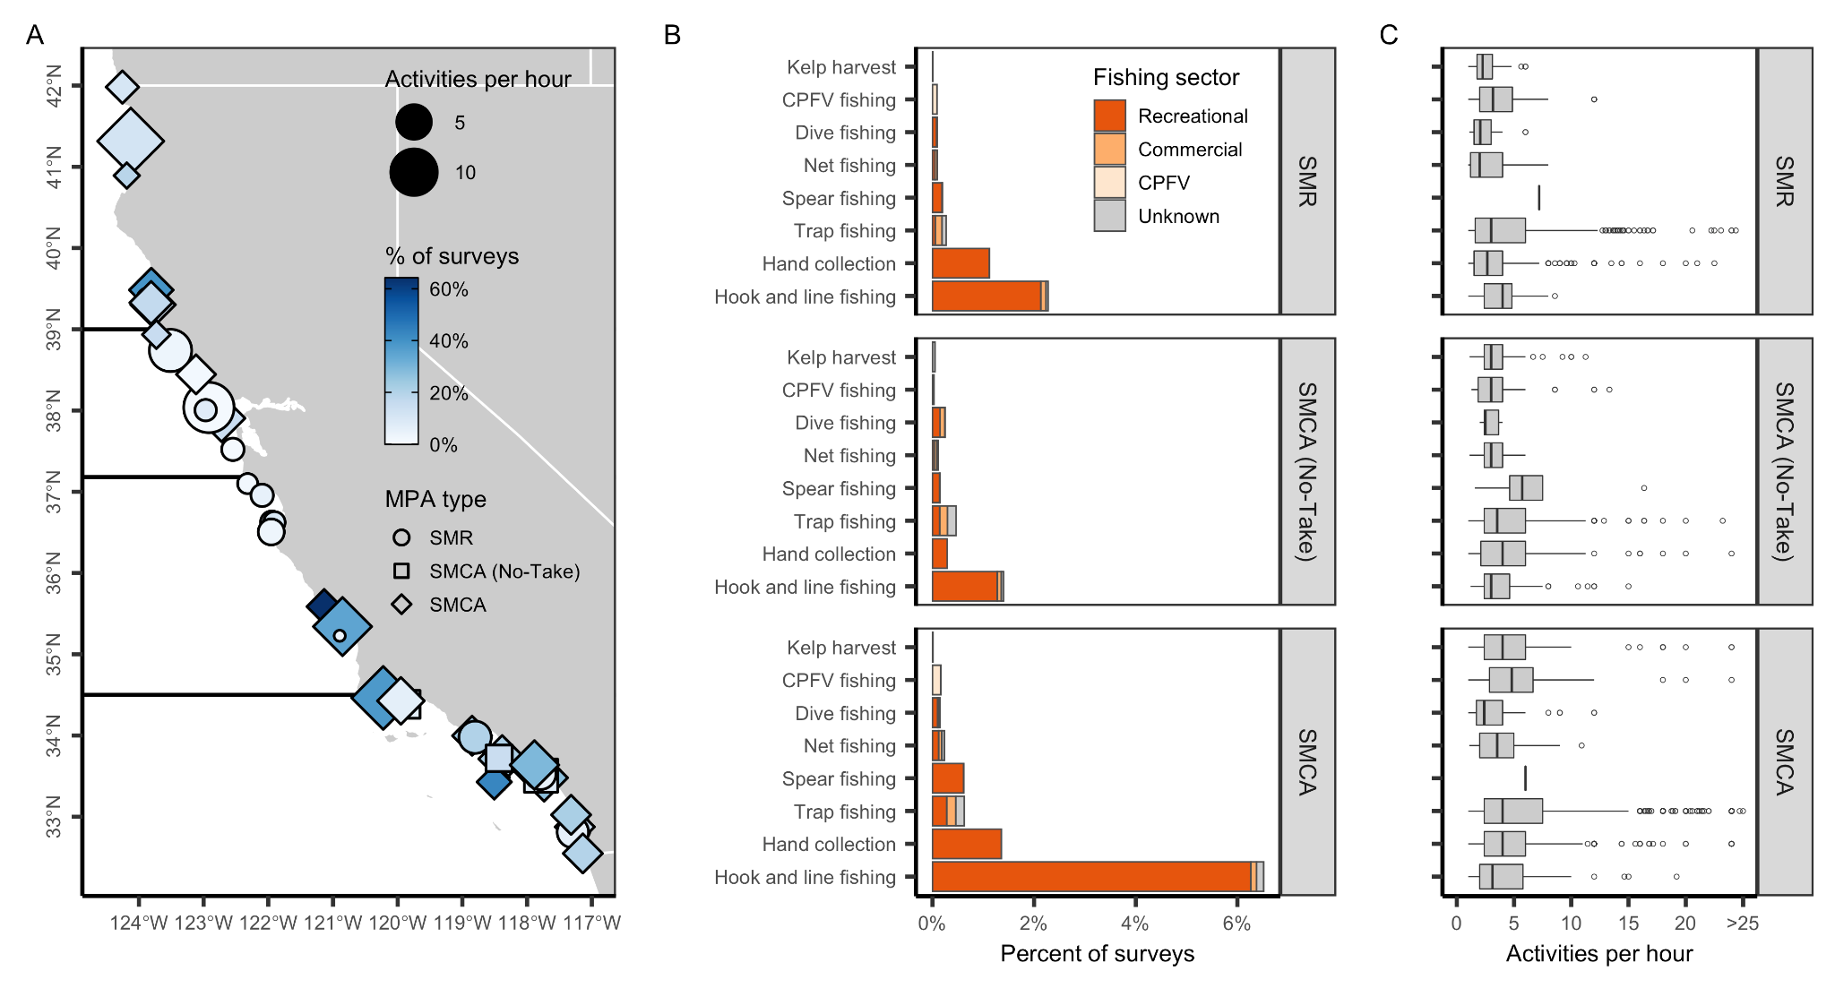**Figure S7.** Active consumptive activities in California’s state marine protected areas (MPAs) based on surveys conducted by MPA Watch. Two SMRMAs are categorized as SMCAs to increase visibility. Panel **A** shows the percent of surveys within MPAs of varying levels of protection (point shape) in which active consumptive activities were observed (color ramp) and the median number of active consumptive activities observed per hour (point size) for surveys in which such activities were observed (i.e., zeroes excluded). Dark horizontal lines delineate the four MLPA regions. Panel **B** shows the percent of surveys in which active consumptive activities were observed by fishing sector (CPFV=commercial passenger fishing vessel). Panel **C** shows the number of active consumptive activities observed per hour for surveys in which such activities were observed (i.e., zeroes excluded). In the boxplots, the solid line indicates the median, the box indicates the interquartile range (IQR; 25th to 75th percentiles), the whiskers indicate 1.5 times the IQR, and the points beyond the whiskers indicate outliers.

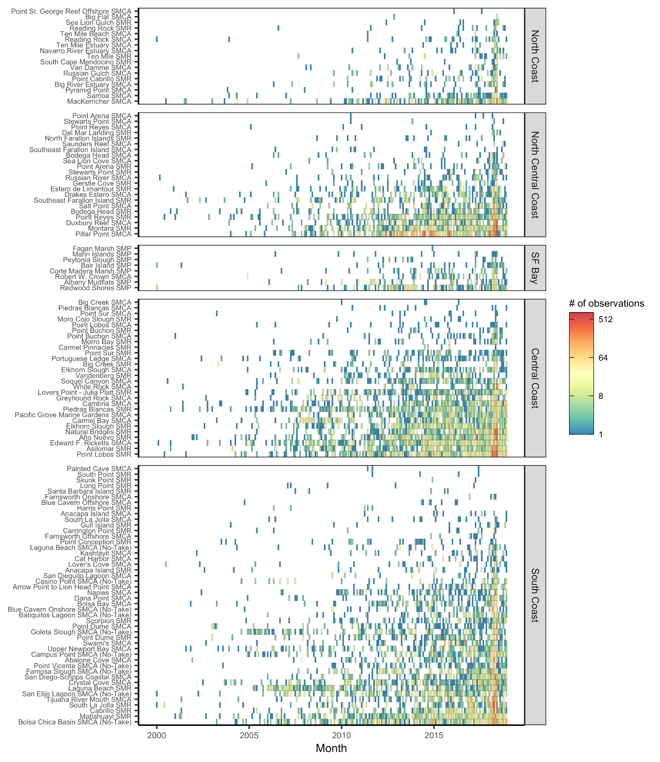

**Figure S8.** Coverage of iNaturalist observation data over time by marine protected area (MPA). Note log-scale for fill color. MPAs are listed in order of overall sample size within each region.

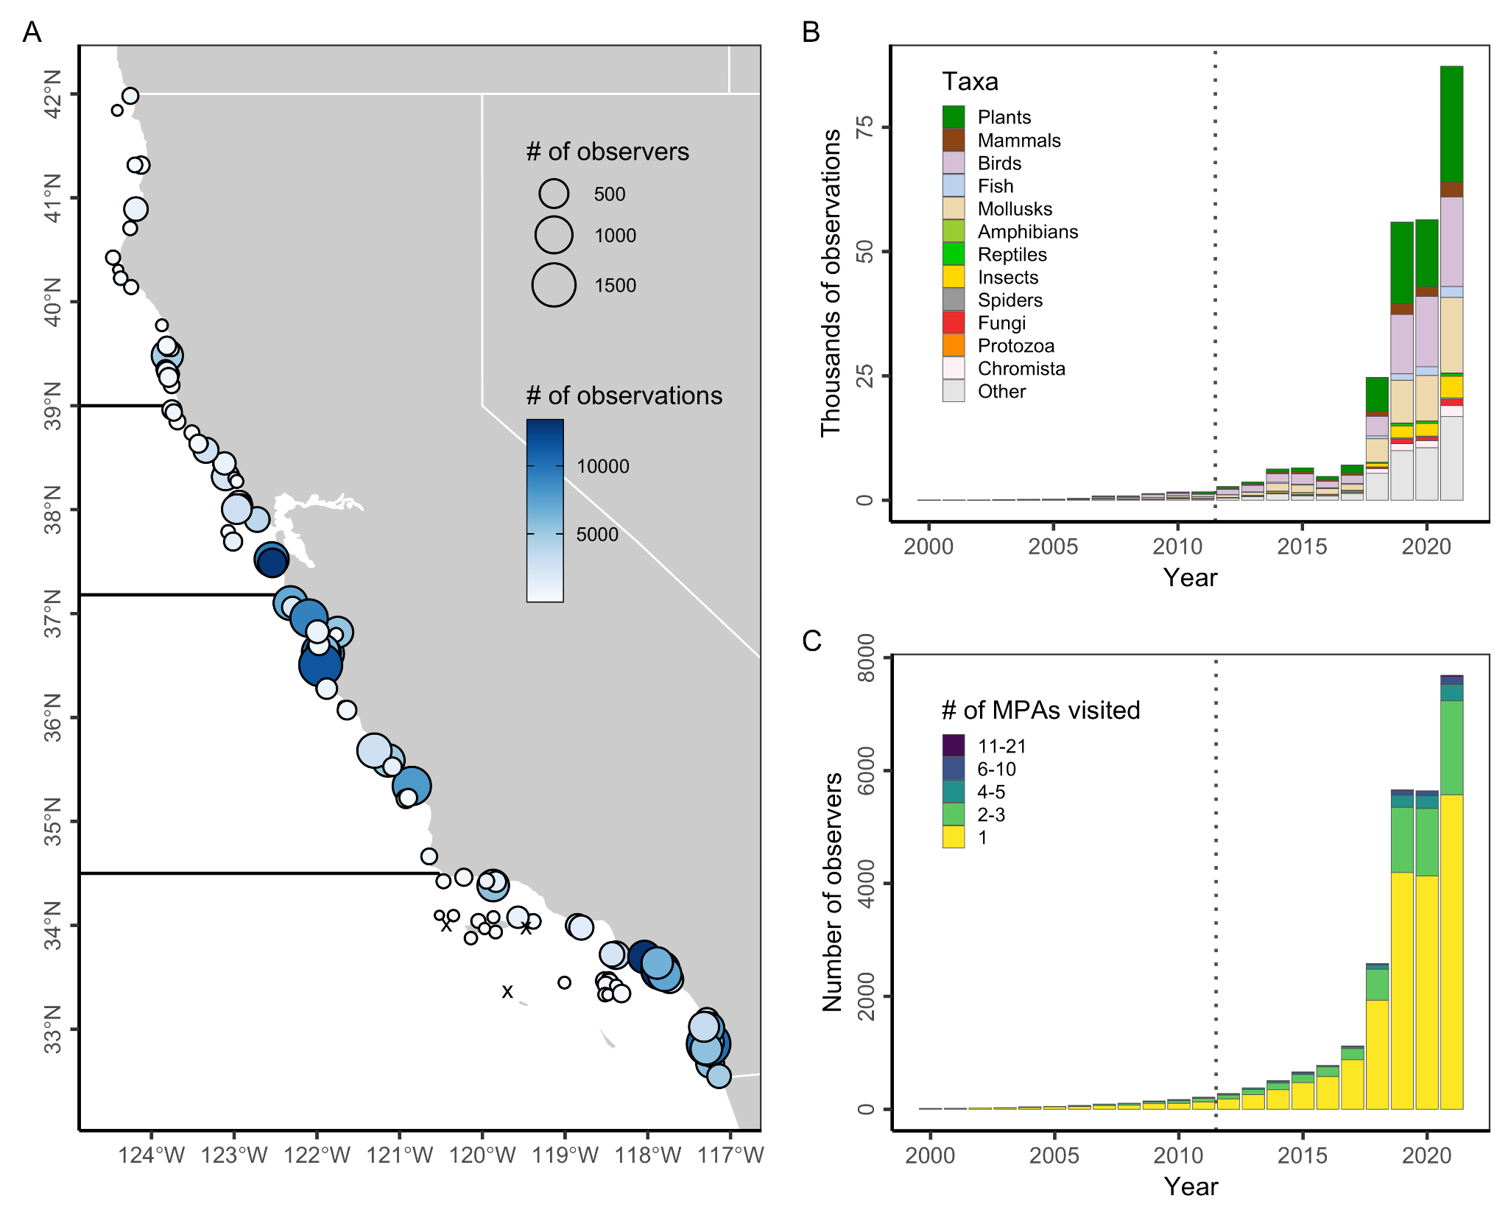**Figure S9.** Human interest in wildlife within California’s state marine protected areas (MPAs) based on usage of the iNaturalist web- and app-based application. Panel **A** shows the number of observers (point size) and observations (color ramp) within 100 m of California’s MPAs from 2012 through 2021. Note log-scale in fill color. Black x’s mark the 4 MPAs without any iNaturalist submissions. Dark horizontal lines delineate the four MLPA regions. Panel **B** shows the number of observations made within 100 m of California MPAs from 2000-2021 by taxonomic group. Panel **C** shows the number of observers making observations within 100 m of California MPAs from 2000-2021 grouped by the number of MPAs that they visited.

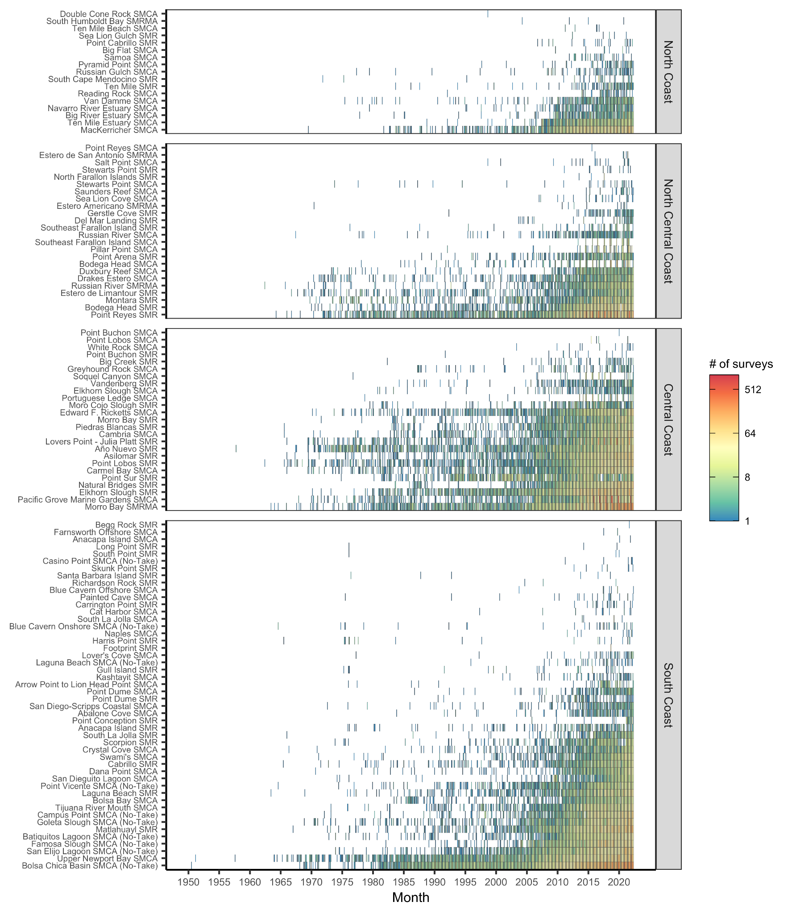**Figure S10.** Coverage of eBird observation data over time by marine protected area (MPA). Note log-scale for fill color. MPAs are listed in order of overall sample size within each region.

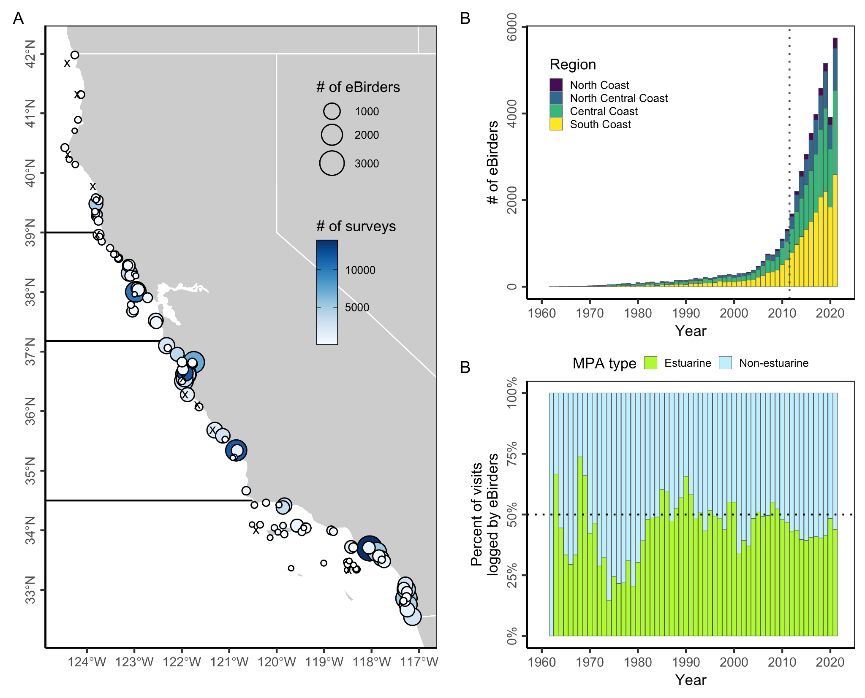

**Figure S11.** Human engagement in birding within California’s state marine protected areas (MPAs) based on submissions to the eBird citizen science program. Panel **A** shows the total number of eBirders (point size) and surveys (color ramp) submitted by eBirders from within 100 m of California’s MPAs from 2012 through 2021. Black x’s mark the 11 MPAs without any eBird submissions. Dark horizontal lines delineate the four MLPA regions. Panel **B** shows the number of eBirders making observations from within 100 m of California MPAs from 1960-2021. Panel **C** shows the percent of visits to MPAs logged by eBirders occurring from within estuarine and non-estuarine MPAs from 1960-2021. Estuarine MPAs represent 2% of the network by area and 17% by count.

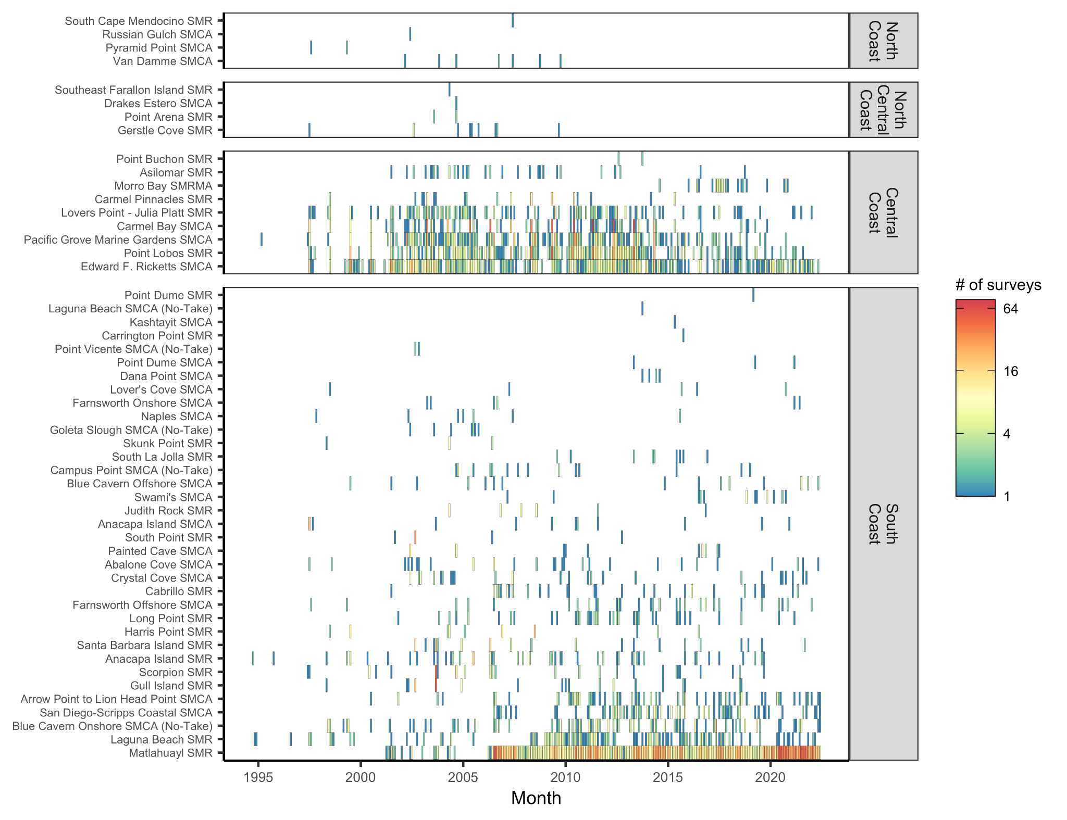**Figure S12.** Coverage of REEF survey data over time by marine protected area (MPA). Note log-scale for fill color. MPAs are listed in order of overall sample size within each region. One San Francisco Bay MPA (Redwood Shores SMP) is plotted in the North Central Region for simplicity.

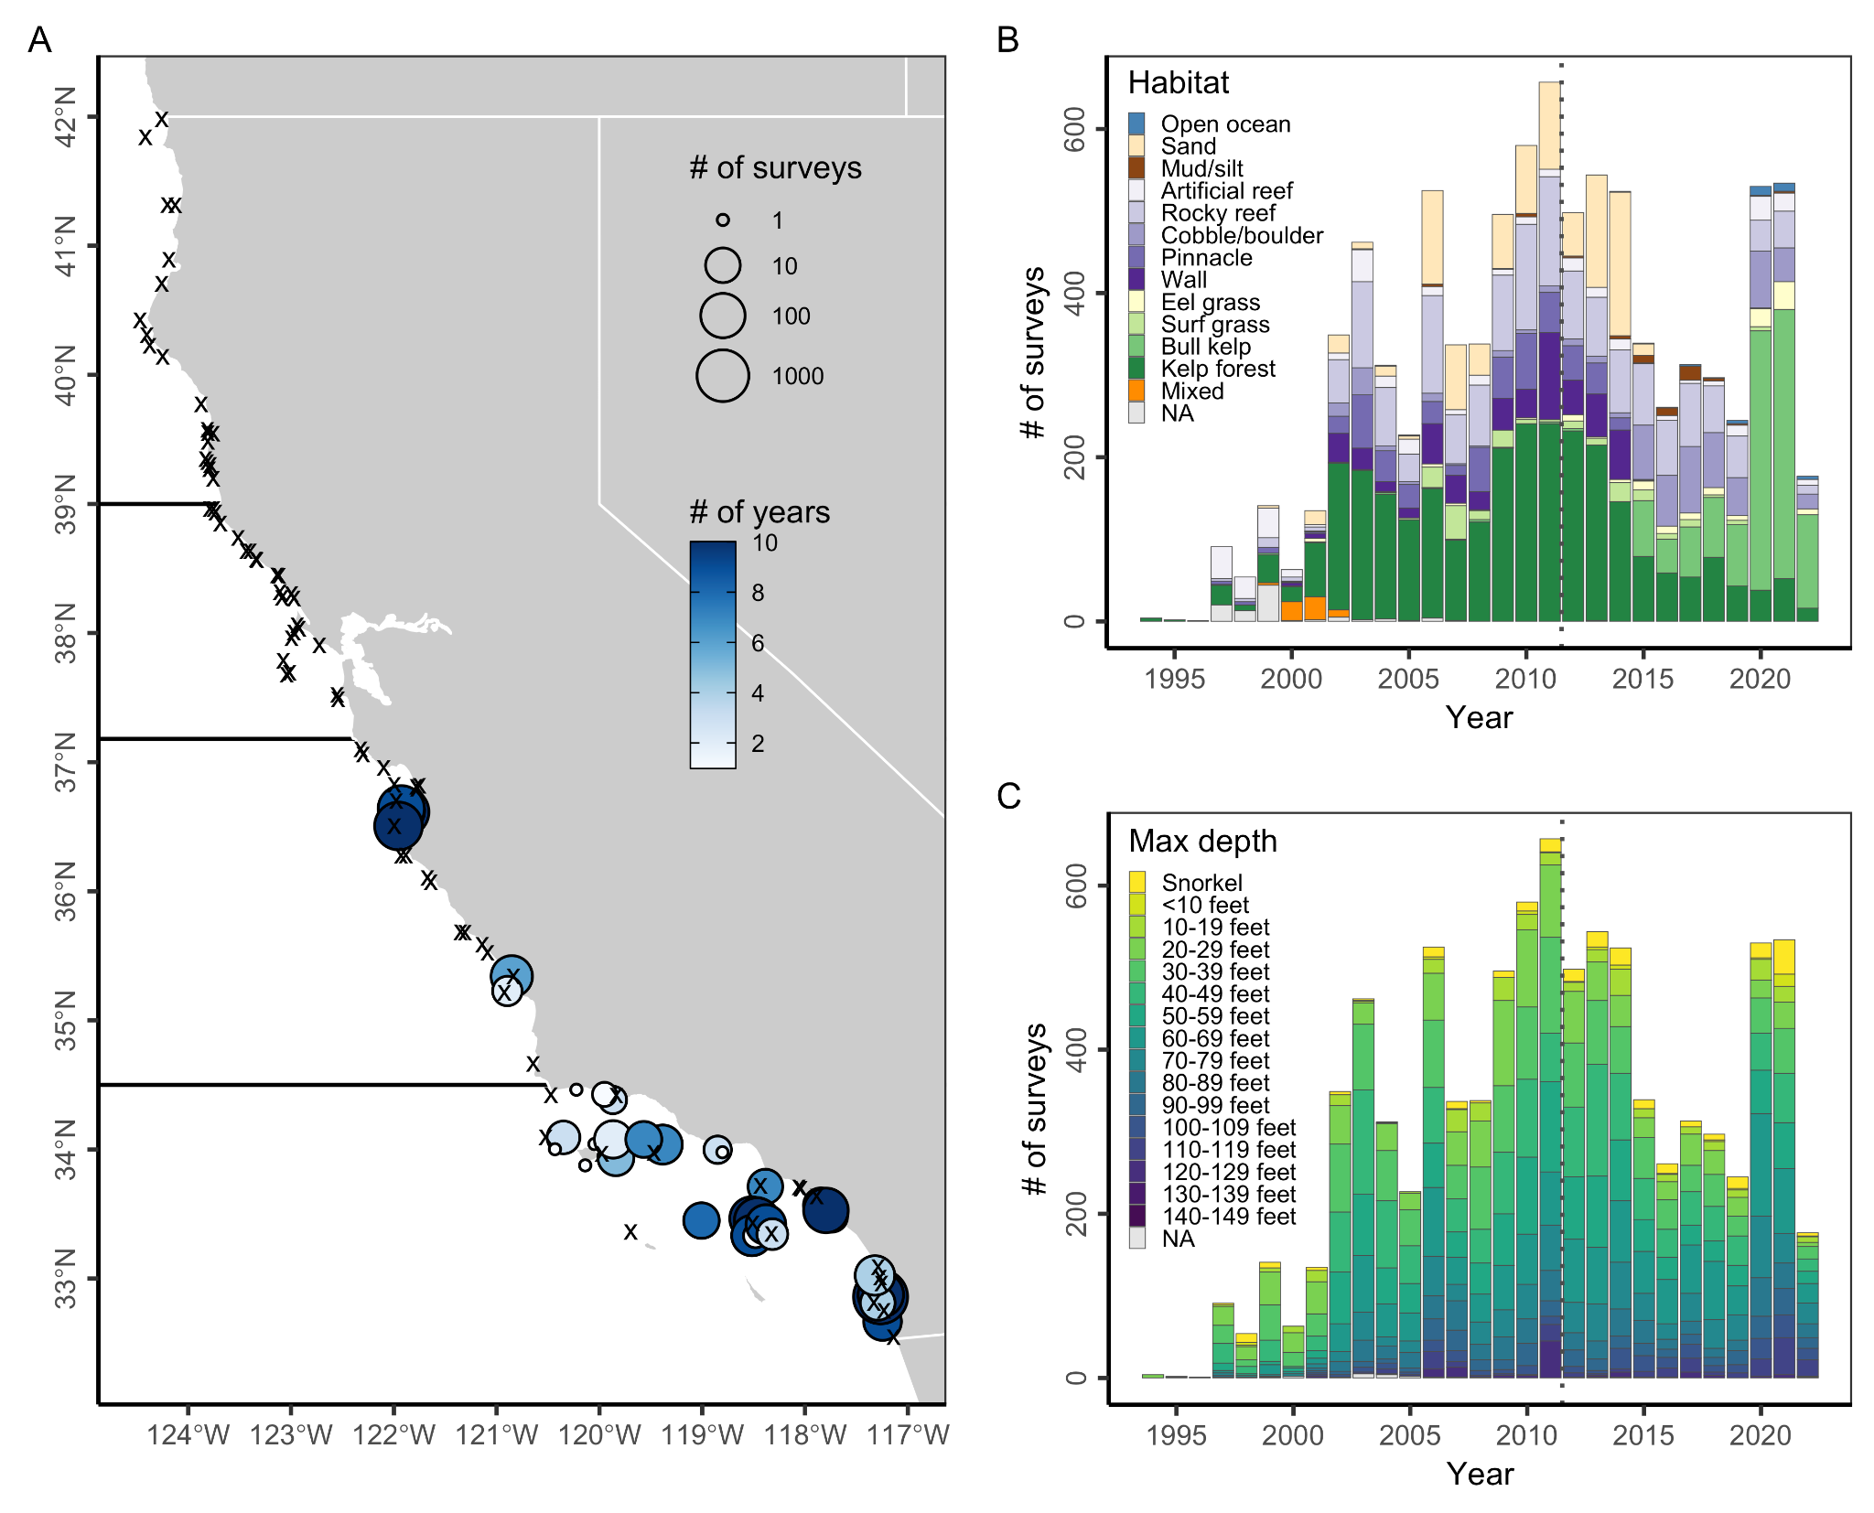

**Figure S13.** Engagement of recreational divers and snorkelers in the REEF citizen science survey program within California’s state marine protected areas (MPAs). Panel **A** shows the number of surveys (point size) conducted in California’s MPAs from 2012 through 2021 and the number of years with survey data (color ramp) for each MPA. Note log-scale in point size. Black x’s mark the 83 MPAs without any REEF surveys. Dark horizontal lines delineate the four MLPA regions. Panel **B** shows the number of surveys within California’s MPA network from 1994-2022 by habitat type. Panel **C** shows the number of surveys within California’s MPA network from 1994-2022 by depth zone.

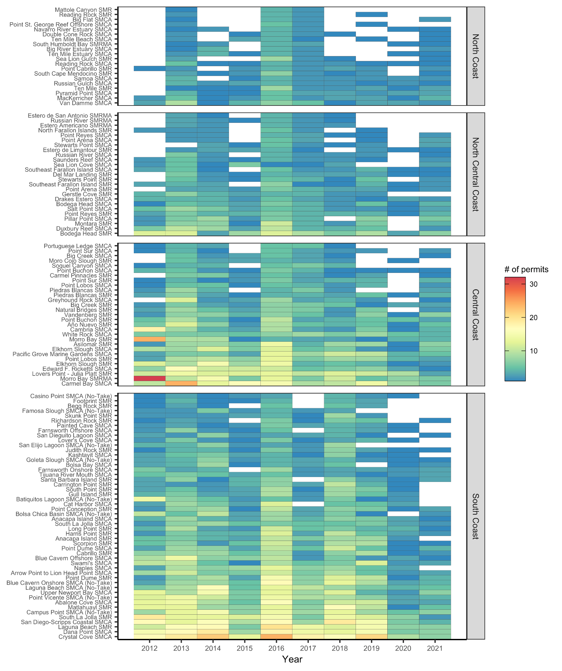**Figure S14.** Number of scientific permits issued annually from 2012 to 2021 by marine protected area (MPA). MPAs are listed in order of overall sample size within each region.

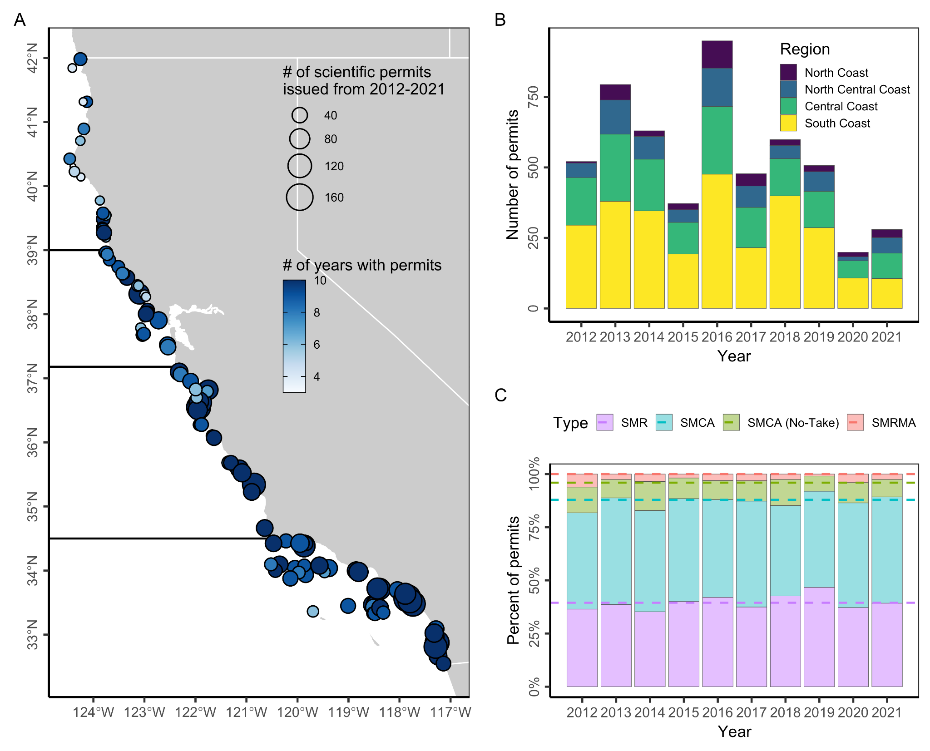**Figure S15.** Number of scientific permits issued for research within California's state marine protected areas (MPAs) from 2012 through 2021. Panel **(A)** shows the number of scientific permits issued (point size) and number of years in which permits were issued (color ramp) for each MPA. Dark horizontal lines delineate the four MLPA regions. In **(B)**, bars indicate the percentage of annual permits issued to MPAs of different designations and lines indicate the representation of MPAs of those designations in the network.

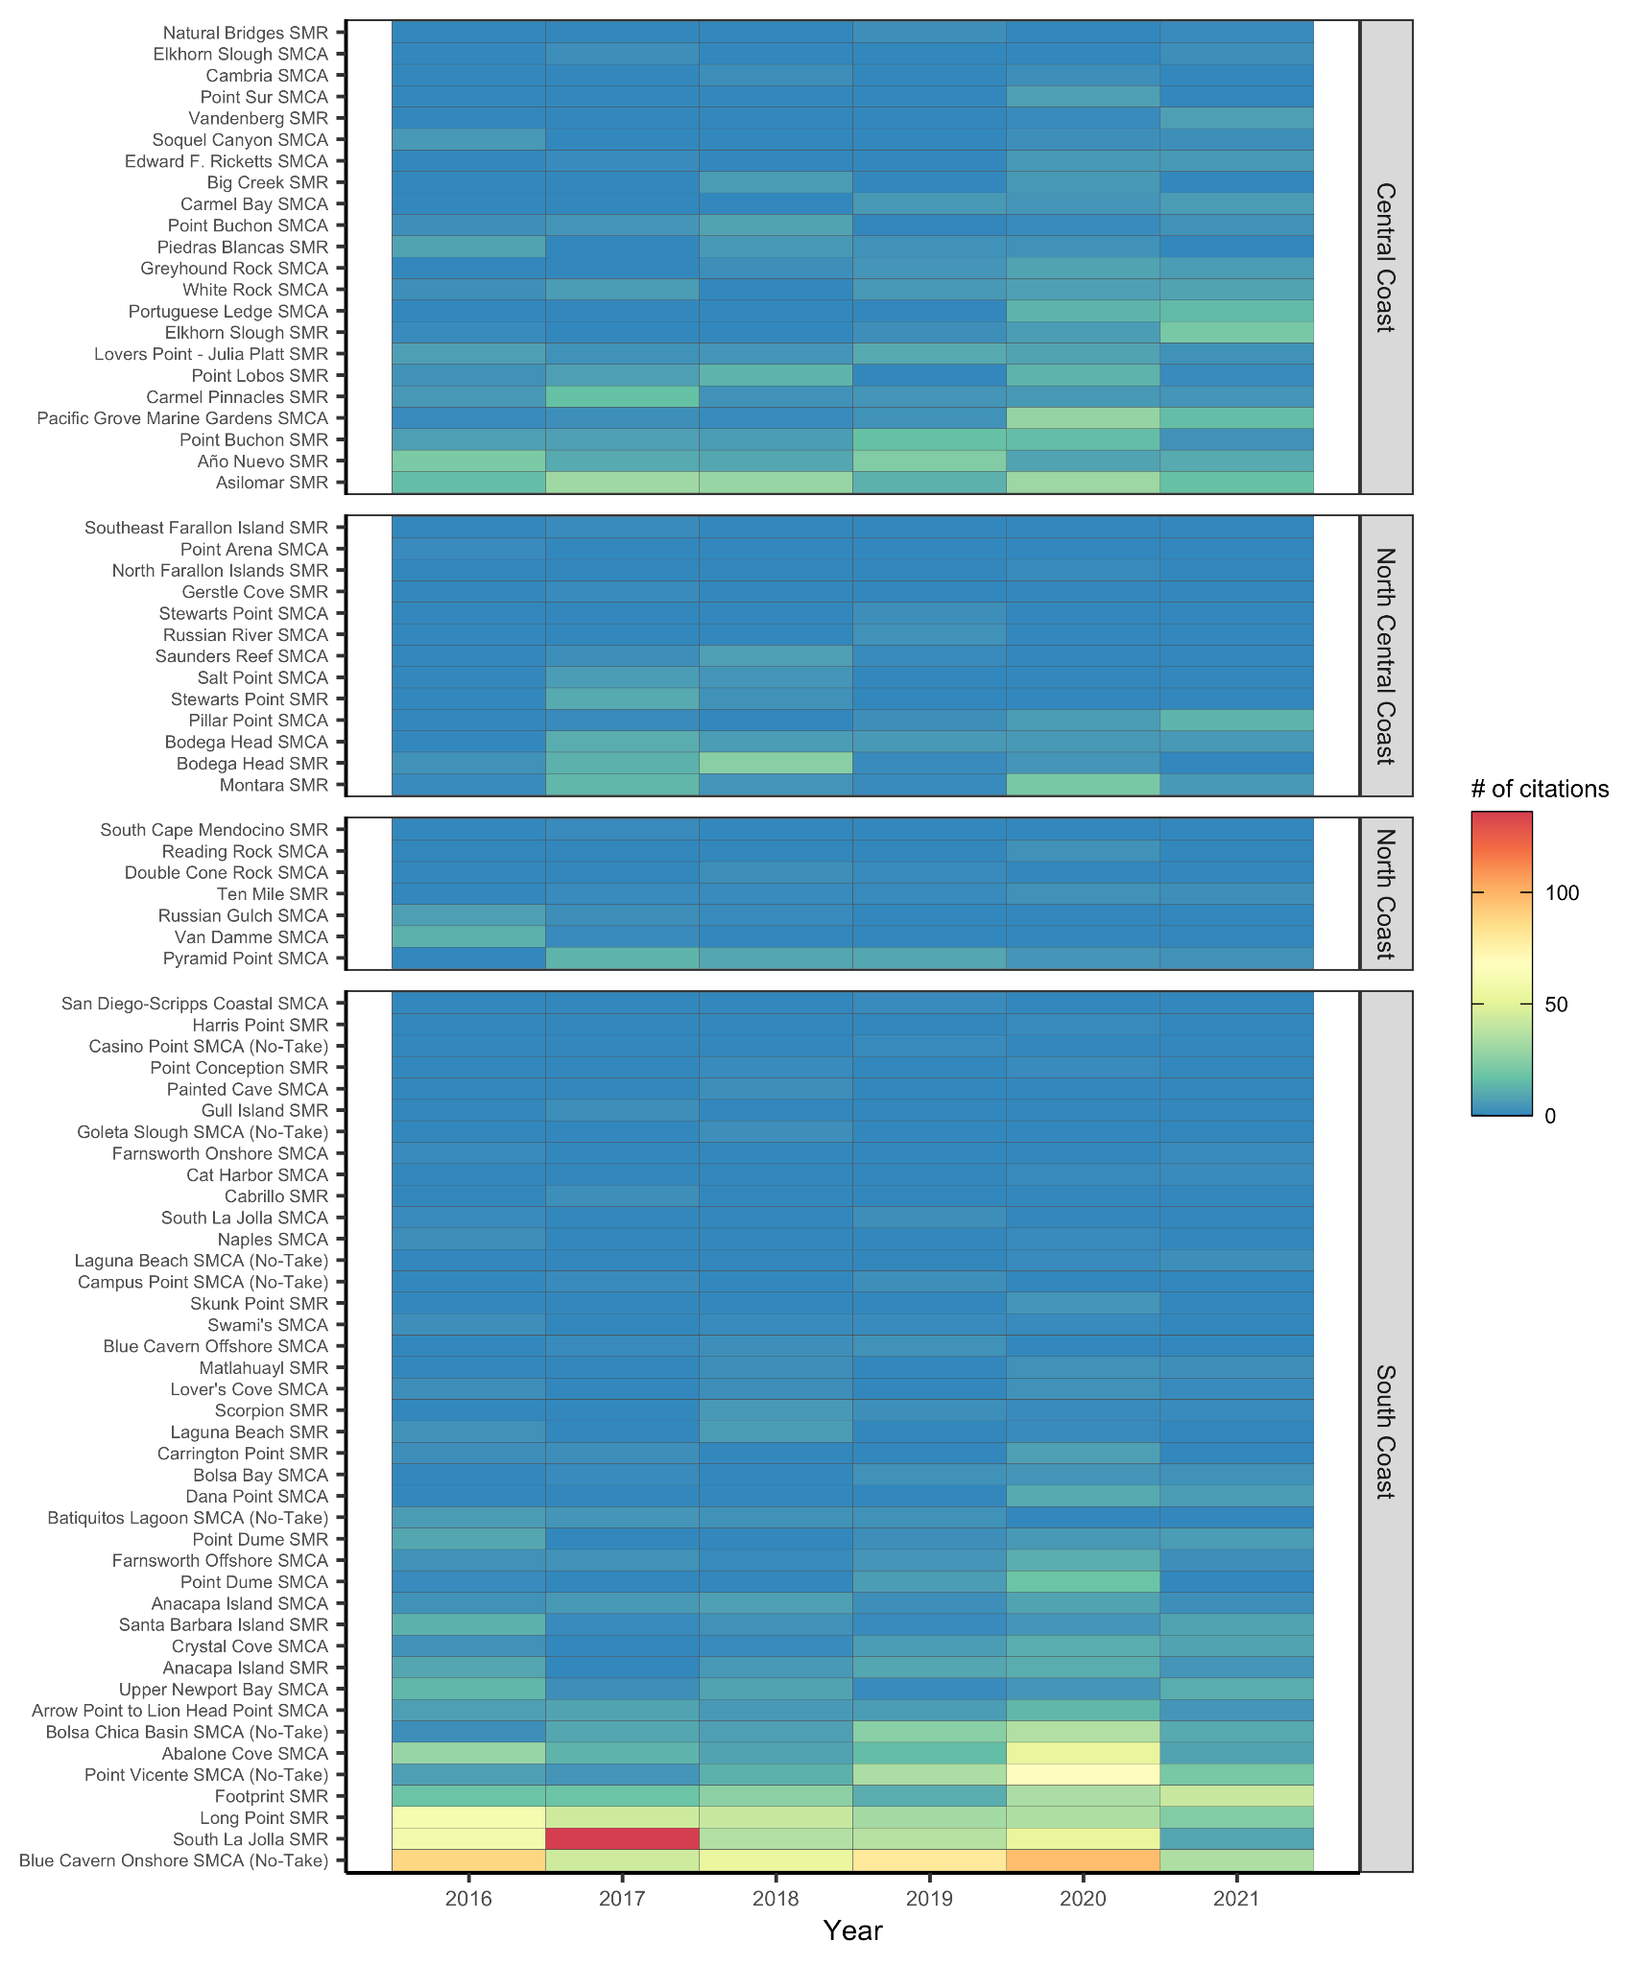

**Figure S16.** Number of citations issued by CDFW Law Enforcement for regulatory violations occurring within California’s MPAs from 2016 to 2021. MPAs are listed in order of overall sample size within each region.

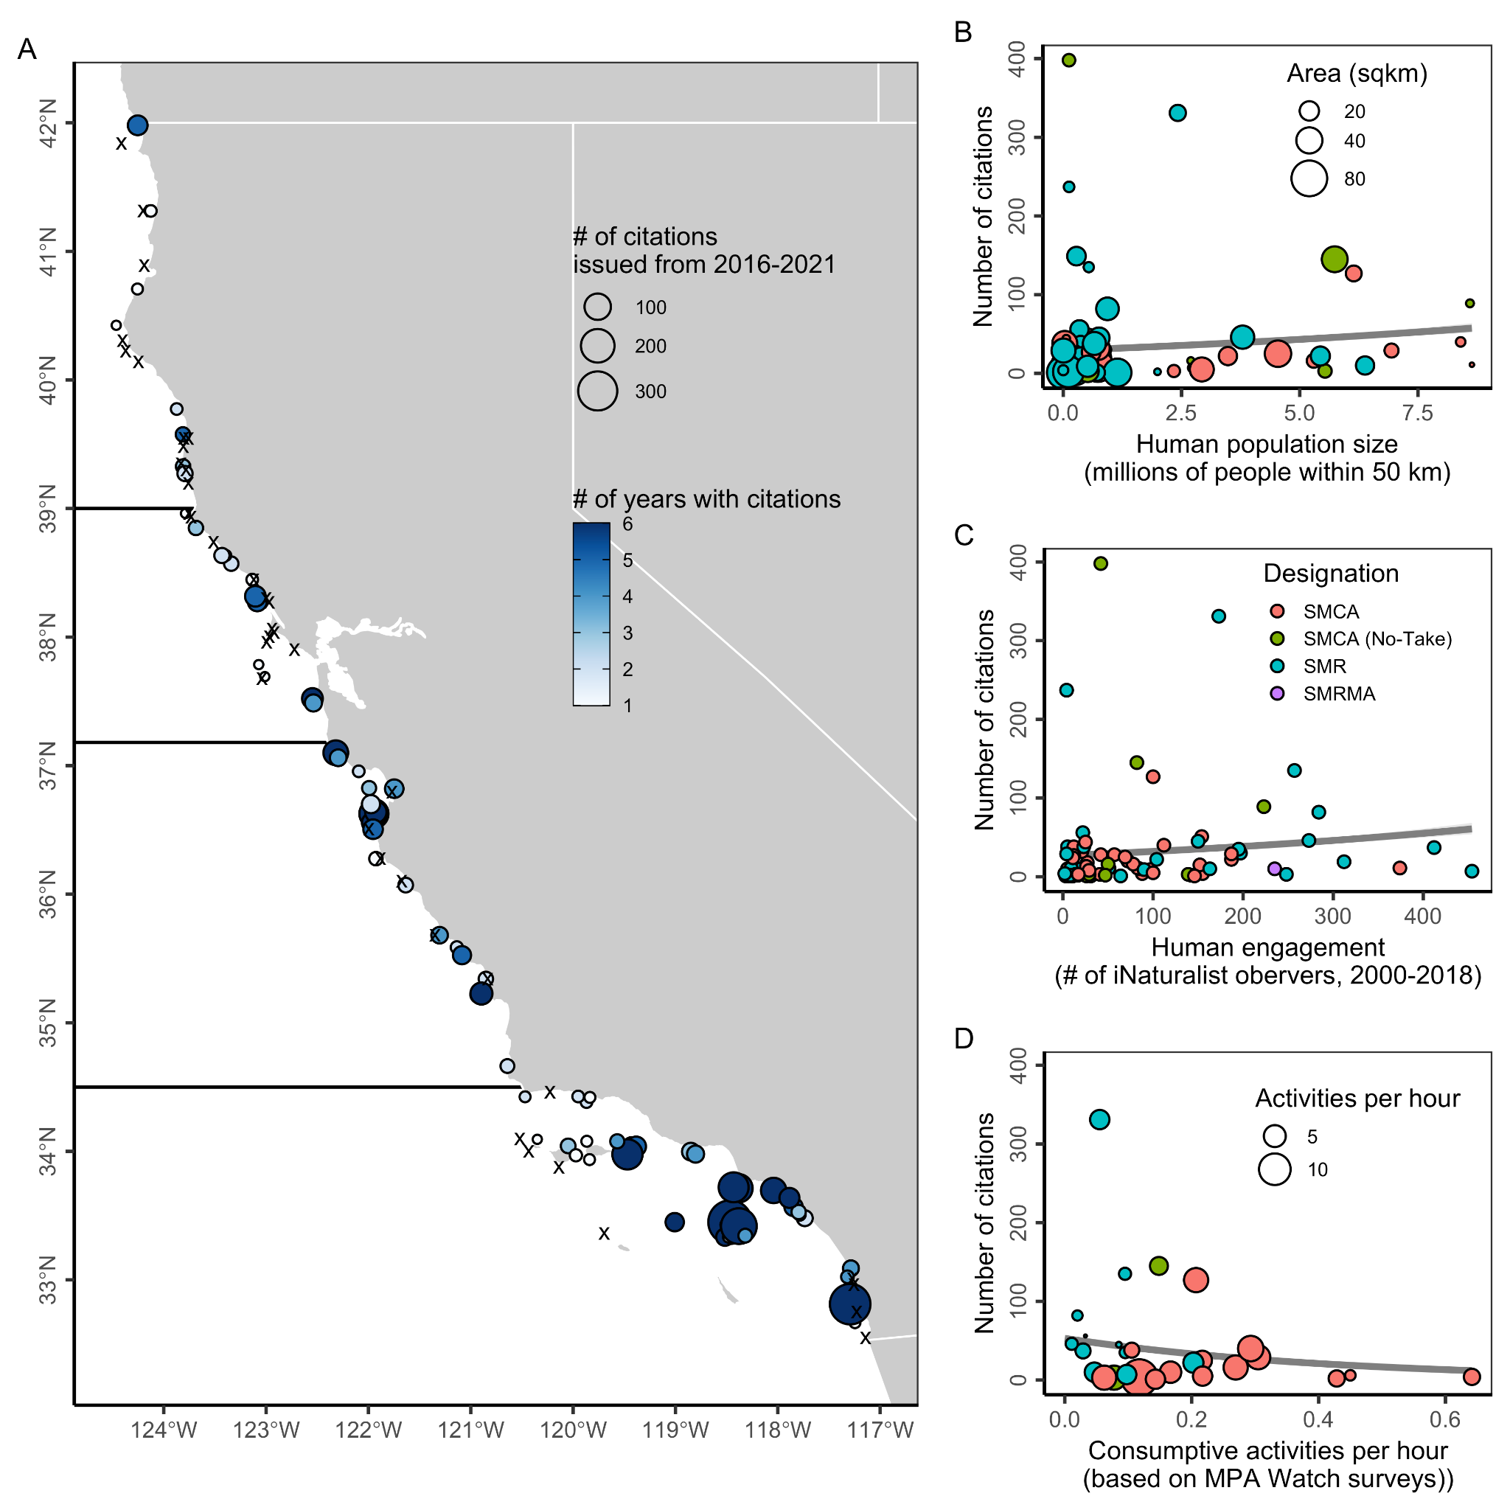**Figure S17.** Number of citations issued by CDFW Law Enforcement for regulatory violations occurring within California's state marine protected areas (MPAs) from 2016 through 2021. In Panel **A**, black x’s mark the 39 MPAs without any citations and dark horizontal lines delineate the four MLPA regions. In Panels **B-D**, the gray line and 95% confidence interval illustrate a generalized linear model assuming a Poisson distribution fit to the data.

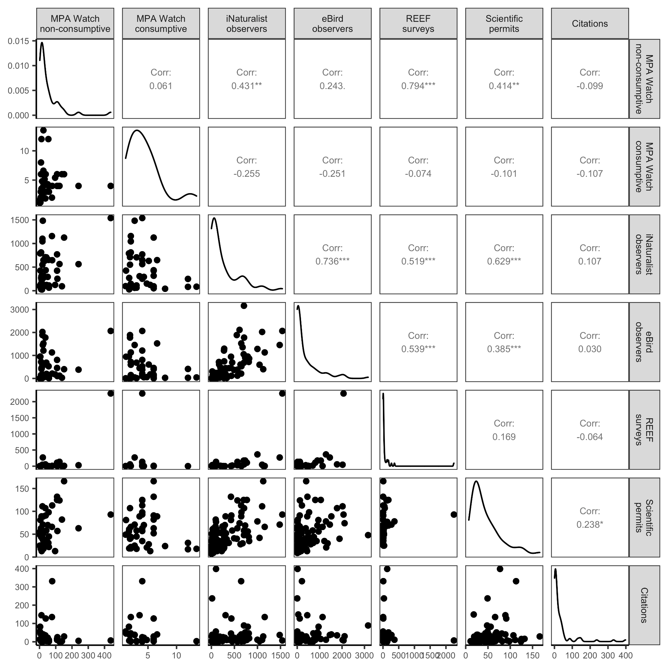**Figure S18.** Correlation between human engagement indicators. The lower section shows pairwise comparisons of engagement indicators. The upper section shows the correlation between each pairwise combination of indicators and the statistical significance of this correlation (* = p < 0.05; ** = p < 0.01; and *** = p < 0.001). The diagonal indicates the distribution of each engagement indicator. See **Table S3** for the choice of displayed indicator.

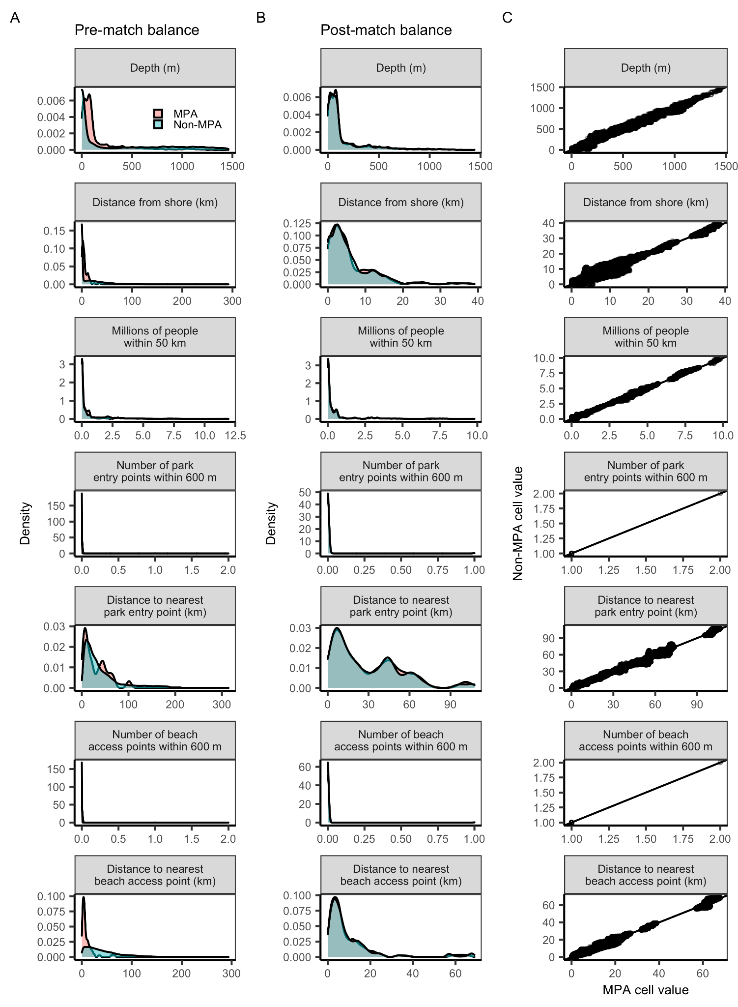

**Figure S19.** The balance of matching variables **(A)** pre- and **(B)** post-matching and the **(C)** correlation between the values of MPA and matched non-MPA raster cells. In **(C)**, the black line is the one-to-one line.

**Table S1.** California marine protected area (MPA) designations.

|  |  |  |
| --- | --- | --- |
| **Designation** | **# / area (km2)** | **Restrictions** |
| ***State marine protected areas*** | ***124 / 2207 km2*** |  |
| State marine reserve (SMR) | 49 / 1229 km*2* | Prohibits comm/rec take of all marine resources* |
| State marine conservation area (SMCA) | 60 / 880 km*2* | Prohibits comml/rec take of selected marine resources |
| State marine conservation area (no take) | 10 / 86 km*2* | Prohibits comm/rec take of all marine resources but allows permitted activities that cause damage (e.g., dredging) |
| State marine recreational management area (SMRMA) | 5 / 12 km*2* | Limits comm/rec take of marine resources but allows legal waterfowl hunting |
| ***Other state management areas*** | ***22 / 20 km2*** |  |
| State marine park (SMP) - all in SF Bay | 7 / 17 km*2* | Prohibits damage or commercial take of all marine resources; recreational take is allowed |
| State marine conservation area (SMCA) - SF Bay | 1 / 0 km*2* | Prohibits comml/rec take of selected marine resources |
| Special closure | 14 / 8 km*2* | Prohibits or restricts activities in waters adjacent to seabird rookeries or marine mammal haul-out sites |
| ***Federal marine protected areas*** | ***9 / 394 km2*** |  |
| Federal marine reserve (FMR) | 8 / 388 km*2* | Extends SMRs around the Channel Islands into federal waters |
| Federal marine conservation area (FMCA) | 1 / 6 km*2* | Extends SMCAs around the Channel Islands into federal waters |

* Marine resources can be living, geologic, or cultural

**Table S2.** Social vulnerability indicators and metrics used to calculate the social vulnerability index. Direction of influence indicates whether the metric was assumed to increase (positive) or decrease (negative) vulnerability. Data used were from the 2010 American Community Survey. Geographic unit for all data is the census tract.

|  |  |
| --- | --- |
| **Indicator** | **Direction of Influence** |
| *Housing Characteristics* |  |
| Median monthly mortgage (USD) | Negative |
| Median monthly rent (USD) | Negative |
| Median number of rooms per housing unit | Negative |
| Percent of all family households that live in mobile homes | Positive |
| *Labor Force Structure* |  |
| Percent of age 16+ population that are working females | Negative |
| Percent of age 16+ population that are working | Negative |
| *Population Composition* |  |
| Percent of families with single females as head of household | Positive |
| Percent of population age 5 and older that speak English less than “very well” | Positive |
| Percent of population whose race is white, with no other descriptors | Negative |
| Percent of the population younger than age 6 | Positive |
| *Poverty Status* |  |
| Percent of families living below the poverty line | Positive |
| Percent of people under age 18 living below the poverty line | Positive |
| Percent of people receiving cash assistance or SNAP payments | Positive |
| Percent of people age 65 and over living below the poverty line | Positive |

**Table S3.** Indicators of human engagement evaluated in this paper. The bolded metric indicates the metric used in the scorecard and accumulation curve analysis.

|  |  |  |  |
| --- | --- | --- | --- |
| **Indicator and source** | **Description** | **Metrics** | **Limitations** |
| MPA Watch (www.mpawatch.org) | **Recreation:** MPA Watch is a community science program that trains volunteers to observe and collect data on human uses of protected areas [(MPA Watch, 2022b)](https://www.zotero.org/google-docs/?HSrpFe). Volunteers use a standardized survey protocol [(MPA Watch, 2022a)](https://www.zotero.org/google-docs/?PLffbb) to record consumptive (e.g., fishing) and non-consumptive (e.g., surfing, boating, tidepooling, running, etc.) activities occurring offshore and onshore of coastal sampling sites. | **(1) the median number of activities observed per hour for surveys in which activities were observed (i.e., zeroes excluded);** (2) percent of surveys in which an activity was observed | There is limited ability to infer the legality of the consumptive activity observed by MPA Watch volunteers because some MPAs allow some forms of harvest and MPA Watch volunteers, while well-trained, are not legal authorities on MPA boundaries and regulations. |
| iNaturalist (www.inaturalist.org) | **Recreation/education:** iNaturalist is a web- and app-based platform that allows observers to submit wildlife photos for identification by amateur and professional naturalists [(iNaturalist, 2022)](https://www.zotero.org/google-docs/?Unmwvc). | **(1) number of iNaturalist users who submitted observations**; (2) number of submitted observations | Participation in iNaturalist largely depends on smartphone ownership and fluency and likely represents a biased (younger, wealthier) demographic. |
| eBird  (www.ebird.org) | **Recreation/education:** eBird is a global citizen science program that collates observations of birds submitted by birdwatchers [(eBird, 2022)](https://www.zotero.org/google-docs/?gK2fht). | **(1) number of eBird users who submitted observations;** (2) number of submitted observations | Participation in eBird is eased by smartphone ownership and fluency and likely represents a biased (younger, wealthier) demographic. |
| REEF  (www.reef.org) | **Recreation/education:** REEF is an international marine conservation organization that trains volunteer divers and snorkelers to collect and report information on marine fish and selected invertebrate and algae species [(REEF, 2022)](https://www.zotero.org/google-docs/?IryJCQ). | **(1) number of surveys conducted;** (2) number of years in which a survey was conducted | The REEF Program is based in southern California and trainings are largely conducted in this area. As a result, participation is greatly biased towards southern California. |
| Scientific permits  (CA Dept. Fish & Wildlife) | **Scientific research:** Permits issued by CDFW for scientific research provide an indicator of scientific research activity throughout California’s MPA network. | **(1) number of permits issued;** (2) number of years in which permits were issued. | There are no apparent limitations to this dataset. However, we note that there are more scientific institutions in Southern/Central CA than Northern CA and that conditions for fieldwork are worse in Northern CA. |
| Law enforcement citations  (CA Dept. Fish & Wildlife) | **Non-compliance:** Regulatory citations from CDFW’s Law Enforcement Division provide an indicator of where non-compliance occurs throughout California’s MPA network. | **(1) number of citations issued;** (2) number of years in which citations were issued. | The lack of effort information (e.g., number of patrol hours) associated with the citation frequency data limits ability to infer non-compliance rates. For example, high frequency could reflect either greater enforcement activity or greater illegal activity. |

**Table S4.** Human use activities recorded by MPA Watch volunteers.

​

|  |  |  |
| --- | --- | --- |
| **Activity type** | **Activity** | **Subcategories** |
| *Non-consumptive* |  |  |
| Onshore recreation | Beach recreation | sandy/rocky |
| Onshore recreation | Wildlife watching | sandy/rocky |
| Onshore recreation | Domestic animals | sandy/rocky; on/off leash |
| Onshore recreation | Driving on the beach |  |
| Onshore recreation | Tide-pooling |  |
| Offshore recreation | Offshore recreation (e.g. swimming) |  |
| Offshore recreation | Surfing |  |
| Offshore recreation | Other board sports |  |
| Offshore recreation | SCUBA diving or snorkeling |  |
| Boating | Kayaking |  |
| Boating | Paddleboarding |  |
| Boating | Other paddleboating |  |
| Boating | Sailing |  |
| Boating | Windsurfing |  |
| Boating | Jet skiing |  |
| Boating | Power boating |  |
| Boating | Whale watch boat |  |
| Boating | Dive boat |  |
| Boating | Work boat |  |
| Boating | Law enforcement boat |  |
| Boating | Other boating |  |
| *Consumptive* |  |  |
| Fishing | Hand collection of biota | sandy/rocky |
| Fishing | Hook and line fishing | onshore/boat; sandy/rocky (if shore); rec/comm/unknown (if boat); active/inactive (if boat) |
| Fishing | Trap fishing | onshore/boat; sandy/rocky (if shore); rec/comm/unknown (if boat); active/inactive (if boat) |
| Fishing | Net fishing | onshore/boat; sandy/rocky (if shore); rec/comm/unknown (if boat); active/inactive (if boat) |
| Fishing | Spear fishing | onshore/offshore/boat; sandy/rocky (if shore); rec/comm/unknown (if boat); active/inactive (if boat) |
| Fishing | Dive fishing | offshore/boat; rec/comm/unknown (if boat); active/inactive (if boat) |
| Fishing | Kelp harvesting | active/inactive |
| Fishing | Passenger fishing | active/inactive/unknown |
| Fishing | Unknown fishing |  |

**Table S5.** Sources of explanatory variables included in logistic regressions evaluating traits associated with charismatic and underutilized MPAs.

|  |  |
| --- | --- |
| **Variable** | **Source** |
| *Design feature* |  |
| MPA age (yr) | CDFW (2019) MPA GIS file.  Available at: https://filelib.wildlife.ca.gov/Public/R7_MR/MANAGEMENT/MPA/ |
| MPA size (km2) | CDFW (2019) MPA GIS file.  Available at: https://filelib.wildlife.ca.gov/Public/R7_MR/MANAGEMENT/MPA/ |
| Protection status  (no-take, some take) | CDFW (2019) MPA GIS file.  Available at: https://filelib.wildlife.ca.gov/Public/R7_MR/MANAGEMENT/MPA/ |
| *Habitat type* |  |
| Sandy beach (km) | CDFW MPA habitat mapping |
| Rocky intertidal (km) | CDFW MPA habitat mapping |
| Estuary (km) | CDFW MPA habitat mapping |
| Maximum kelp canopy (km2) | CDFW MPA habitat mapping |
| *Accessibility and amenities* |  |
| Distance to port (km) | CDFW (2022) Fishing ports. Available from CDFW. |
| Number of parks within 1 km | ESRI (2022) USA Parks.  Available at: https://www.arcgis.com/home/item.html?id=578968f975774d3fab79fe56c8c90941 |
| Number of parking lots within 1 km | CDPR (2022) Parking. California Department of Parks and Recreation.  Available at: https://www.parks.ca.gov/?page_id=29682 |
| Number of picnic areas within 1 km | CDPR (2022) Picnic Grounds. California Department of Parks and Recreation.  Available at: https://www.parks.ca.gov/?page_id=29682 |
| Number of campgrounds within 1 km | CDPR (2022) Campgrounds. California Department of Parks and Recreation.  Available at: https://www.parks.ca.gov/?page_id=29682 |
| *Social vulnerability* |  |
| Social vulnerability index | See methods for details. |

**Table S6.** Matching variables used in the design of counterfactual areas and their sources.

|  |  |
| --- | --- |
| **Matching variable** | **Source** |
| Depth (m) | CDFW (2011) Bathymetry. California Department of Fish and Wildlife. Available at: https://filelib.wildlife.ca.gov/Public/R7_MR/BATHYMETRY/ |
| Distance from shore (km) | CDFW (2011) Coastline. California Department of Fish and Wildlife. Available at: https://filelib.wildlife.ca.gov/Public/R7_MR/BASE/ |
| Number of people within 50 km | USCB (2010) US Census Data. United States Census Bureau. Available at: https://www.census.gov/programs- surveys/decennial- census/decade/2010/about-2010.html |
| Number of park entry points within 600 m | CDPR (2022) Park Entry Points. California Department of Parks and Recreation. Available at: https://www.parks.ca.gov/?page_id=29682 |
| Distance to nearest park entry point (m) | CDPR (2022) Park Entry Points. California Department of Parks and Recreation. Available at: https://www.parks.ca.gov/?page_id=29682 |
| Number of public beach access points within 600 m | CCC (2022) Public Access Points. California Coastal Commission. Available at: https://gis.data.ca.gov/datasets/coastalcomm::public-access-points/about |
| Distance to nearest public beach access point (m) | CCC (2022) Public Access Points. California Coastal Commission. Available at: https://gis.data.ca.gov/datasets/coastalcomm::public-access-points/about |

**Table S7.** Attributes of ‘charismatic’ and ‘underutilized’ MPAs by type of engagement, based on the results of stepwise logistic regressions. Missing values indicate the best fit model does not include the associated predictors*. In each model, “typical” MPAs were set as the reference level and evaluated against charismatic or underutilized MPAs. Coefficients returned by each model are reported as odds ratio. CI = 95% confidence interval; AIC = Akaike Information Criterion.

|  |  |  |  |  |  |  |
| --- | --- | --- | --- | --- | --- | --- |
|  | **Charismatic vs. typical** | | | **Underutilized vs. typical** | | |
| *Predictors* | *Odds Ratios* | *CI* | *p* | *Odds Ratios* | *CI* | *p* |
| (Intercept) | 0.00 | 0.00 – 0.13 | **0.007** | 0.62 | 0.24 – 1.53 | 0.302 |
| Distance to port (km) | 1.00 | 1.00 – 1.00 | 0.065 | 1.00 | 1.00 – 1.00 | **<0.001** |
| MPA size (km2) | 0.94 | 0.87 – 1.01 | 0.121 |  |  |  |
| Take? (yes/no) | 0.26 | 0.05 – 1.18 | 0.093 |  |  |  |
| Sandy beach (km) | 1.49 | 1.08 – 2.19 | **0.022** | 0.61 | 0.39 – 0.87 | **0.016** |
| MPA age (yr) | 1.58 | 1.15 – 2.29 | **0.007** |  |  |  |
| # of parks within 1 km | 1.28 | 1.09 – 1.56 | **0.006** |  |  |  |
| Rocky intertidal (km) |  |  |  | 0.80 | 0.61 – 1.03 | 0.101 |
| # of parking lots within 1 km |  |  |  | 0.42 | 0.15 – 0.71 | **0.019** |
| Observations | 71 | | | 92 | | |
| R2 Tjur | 0.466 | | | 0.446 | | |
| AIC | 59.527 | | | 84.254 | | |

* Predictors not included in the reduced models include: maxim kelp canopy (km2), estuary extent (km), number of campgrounds within 1 km, number of picnic areas within 1 km (see **Table S5** for details).